**Unit 4. Relational Language**

*4.1. Introduction to SQL*

*4.2. concepts of DDL, DML, DCL*

*4.3. SQL –Data type, operators*

*4.4. structure – creation, alteration, drop, defining constraints – Primary key, foreign key, unique, not null, check, default etc.*

*4.5. Manipulation commands (INSERT, UPDATE, DELETE, SELECT queries)*

*4.5. Functions - aggregate functions, Built-in functions – numeric, date, string functions, set operations, sub-queries, Use of group by, having, order by, LIKE Pattern, Exist, Any, All, BETWEEN, join and its types, view and its types.*

[*https://github.com/sanjeevlcc/notes_2081/blob/main/DBMS_BIM_BSCIT_BCA/BCSIT_PU_CCT/LABS_Annapurna/Unit_4_Relational_Language.txt*](https://github.com/sanjeevlcc/notes_2081/blob/main/DBMS_BIM_BSCIT_BCA/BCSIT_PU_CCT/LABS_Annapurna/Unit_4_Relational_Language.txt)

**4.1. Introduction to SQL**

* SQL (Structured Query Language) is a standard language used to interact with relational database systems. It is a powerful tool to create, manage, and manipulate data stored in relational databases.
* SQL is essential for managing structured data and is used widely in various industries to handle data-driven applications.

**Purpose of SQL**

SQL enables users to:

1. 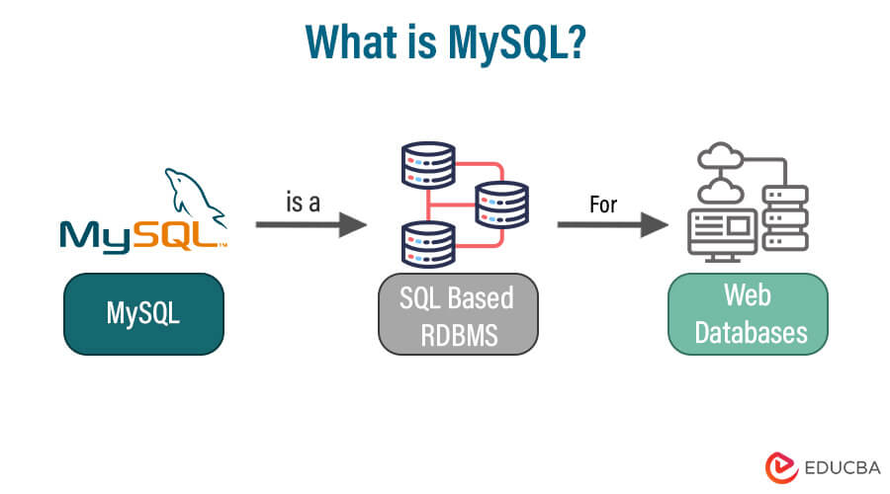**Create and Modify Database Structures**: Define the schema of databases, including tables and their relationships.
2. **Manipulate Data**: Perform operations like inserting, updating, and deleting data.
3. **Retrieve Information**: Query the database to fetch specific data using conditions and filters.
4. **Control Access**: Manage user permissions and roles to ensure data security.

**Features of SQL**

1. 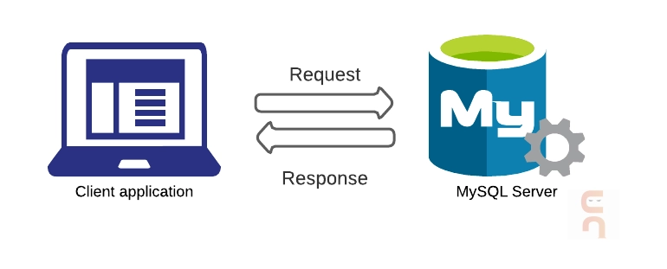**Simplicity**: SQL uses simple and readable commands like SELECT, INSERT, and DELETE.
2. **Versatility**: It can be used to perform a variety of database tasks, from data retrieval to advanced analytics.
3. **Standardization**: SQL is standardized by organizations like ANSI and ISO, ensuring compatibility across multiple database management systems (DBMSs).
4. **Declarative Nature**: Users specify *what* they want, not *how* it should be executed.

**Applications of SQL**

1. **Database Management**: Creating, modifying, and managing database structures.
2. **Data Analysis**: Generating reports and insights from large datasets.
3. **Web and App Development**: Back-end databases for storing and retrieving user data.
4. 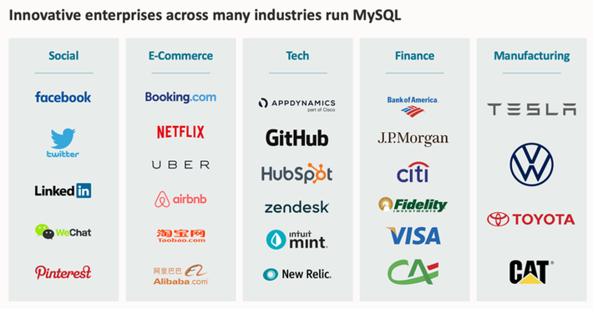**Business Intelligence**: Querying data warehouses for decision-making.

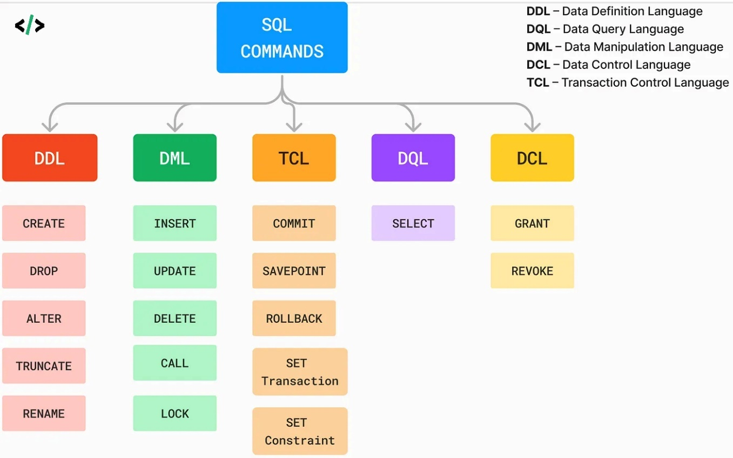**4.2. Concepts of DDL, DML, DCL**

* SQL commands are categorized into three major groups based on their purpose:
  + **DDL (Data Definition Language)**,
  + **DML (Data Manipulation Language)**, and
  + **DCL (Data Control Language)**.
* Each category serves a specific role in managing and manipulating databases.

**1. Data Definition Language (DDL)**

**Purpose**: DDL commands define and modify the structure of database objects like tables, schemas, indexes, and constraints.

**Key DDL Commands:**

1. **CREATE**: Creates new database objects like tables, views, or indexes.
   * Example:

*CREATE TABLE Employees (*

*EmployeeID INT PRIMARY KEY AUTO_INCREMENT,*

*FullName VARCHAR(50) NOT NULL,*

*Gender VARCHAR(10),*

*DepartmentID INT,*

*PhoneNumber VARCHAR(15),*

*Email VARCHAR(50),*

*Address VARCHAR(100),*

*JoinDate DATE,*

*FOREIGN KEY (DepartmentID) REFERENCES Departments(DepartmentID)*

*

1. **ALTER**: Modifies the structure of an existing database object.
   * Example:

*ALTER TABLE Employees ADD Email VARCHAR(100);*

*ALTER TABLE Employees DROP COLUMN Email;*

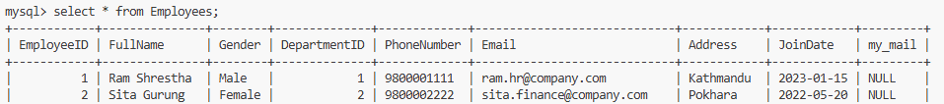

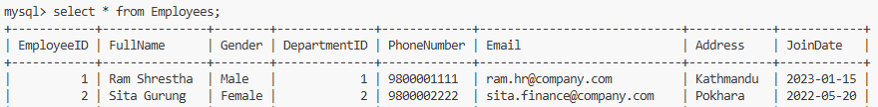

1. **DROP**: Removes database objects such as tables, views, or indexes.
   * Example:

*DROP TABLE t1;*

1. **TRUNCATE**: Removes all rows from a table without logging individual row deletions.
   * Example:

*TRUNCATE TABLE t22;*

**Characteristics of DDL:**

* Changes made by DDL commands are permanent and automatically committed.
* Focuses on database structure, not the data itself.

**2. Data Manipulation Language (DML)**

**Purpose**: DML commands are used to manipulate the data stored in database objects.

**Key DML Commands:**

1. **INSERT**: Adds new records to a table.
   * A screenshot of a computer code

     Description automatically generatedExample: *insert into t22() values(1,"ram"),(2,"sita");*
2. **UPDATE**: Modifies existing data in a table.
   * Example:

*UPDATE t22*

*SET name="sita KC"*

*where id=2;*

1. **DELETE**: Removes specific records from a table.
   * A screenshot of a computer code

     Description automatically generatedExample: *DELETE FROM t22 WHERE id=1;*
2. **SELECT**: Retrieves data from one or more tables.
   * Example:

*select * from t22;*

*******select name from t22;*

**Characteristics of DML:**

* DML commands manipulate the data but do not change the structure of database objects.
* Changes are not automatically committed unless specified (requires COMMIT).

**3. Data Control Language (DCL)**

**Purpose**: DCL commands manage access and permissions for users in the database.

**Key DCL Commands:**

1. **GRANT**: Provides specific permissions to users.
   * Example:

*GRANT SELECT, INSERT ON t22 TO 'user1';*

1. **REVOKE**: Removes specific permissions from users.
   * Example:

*REVOKE INSERT ON t22 FROM 'user1';*

**Characteristics of DCL:**

* Used to enforce security and access control in the database.
* Typically requires administrative privileges.

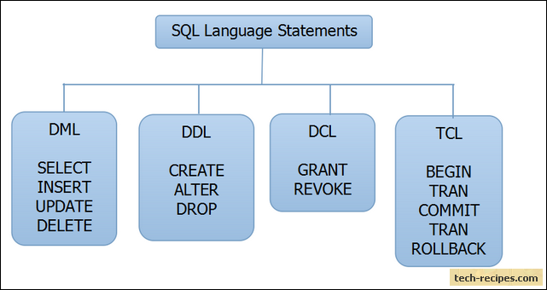

**4.3. SQL – Data type and Operators**

* Data types in SQL define the type of data a column can hold.
* Choosing the correct data type ensures data integrity, efficient storage, and optimized performance.
* SQL data types can be broadly categorized as:
  + ***Numeric Data Types***
  + ***String Data Types***
  + ***Date and Time Data Types***
  + ***Other Data Types***

**A. Numeric Data Types**

Used to store numbers, either integers or real (floating-point) numbers.

**B. String Data Types**

**Used to store text and alphanumeric data.**

**C. Date and Time Data Types**

**Used to store temporal data.**

**D. Other Data Types**

**Used for specific use cases.**

**SQL Operators**

* SQL operators are used to perform operations on data such as comparison,
  + ***logical operations,***
  + ***arithmetic calculations, and***
  + ***pattern matching***
  + ***Other Operators***
* Operators are fundamental in SQL queries and are used in the WHERE clause to filter data, in the SELECT clause to manipulate data, or in various other clauses to modify the results.

**1. Arithmetic Operators**

Arithmetic operators are used to perform basic mathematical operations.

**2. Comparison Operators**

Comparison operators are used to compare two expressions and return a Boolean value (TRUE or FALSE).

**3. Logical Operators**

Logical operators are used to combine multiple conditions in a WHERE clause.

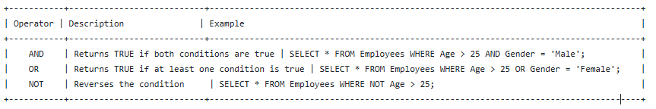

**4. Other Operators**

Other operators include the BETWEEN, IN, and LIKE operators, which allow for more complex queries.

**Questions and Answers**

**Question 1: Data Types**

**Q1: Which SQL data type would you use to store an employee's salary with two decimal places?**

**Solution:** The DECIMAL or NUMERIC data type is used to store fixed-point numbers with precision.

*CREATE TABLE Employees (*

*EmployeeID INT PRIMARY KEY AUTO_INCREMENT,*

*FullName VARCHAR(50) NOT NULL,*

*Salary DECIMAL(10, 2)*

*);*

**Question 2: Operators - Arithmetic**

**Q2: Write an SQL query to calculate the total price after applying a discount of 10% to a product with an original price of 500.**

**Solution:** To calculate the total price after applying a 10% discount, use the subtraction arithmetic operator (-) and multiplication operator (*).

*SELECT 500 - (500 * 0.10) AS DiscountedPrice;*

**Question 3: Operators - Comparison**

**Q3: Write an SQL query to find all employees who have been with the company for more than 2 years.**

**Solution:** Use the DATEDIFF() function and the > comparison operator to find employees who have been with the company for more than 2 years.

*SELECT * FROM Employees*

*WHERE DATEDIFF(CURDATE(), JoinDate) > 365 * 2;*

**Question 4: Data Types - Date**

**Q4: Write an SQL query to find all employees who joined the company in the year 2023.**

**Solution: Use the YEAR() function to extract the year from the JoinDate column.**

*SELECT * FROM Employees*

*WHERE YEAR(JoinDate) = 2023;*

**Question 5: Operators - BETWEEN**

**Q5: Write an SQL query to find all transactions that occurred between '2024-01-10' and '2024-01-25'.**

**Solution:** Use the BETWEEN operator to filter the transactions by date range.

*SELECT * FROM Transactions*

*WHERE TransactionDate BETWEEN '2024-01-10' AND '2024-01-25';*

**Question 6: Data Types - String**

**Q6: Write an SQL query to retrieve all employees whose email ends with '@company.com'.**

**Solution:** Use the LIKE operator with the pattern matching for string values.

*SELECT * FROM Employees*

*WHERE Email LIKE '%@company.com';*

**4.4. Structure – creation, alteration, drop,**

**Defining constraints –**

**Primary key,**

**foreign key,**

**unique,**

**not null,**

**check,**

**default etc.**

<https://github.com/sanjeevlcc/notes_2081/blob/main/DBMS_BIM_BSCIT_BCA/LABS_ON_AIR/2_LAB%201%20-%20creating%20database%20and%20tables%20%2C%20inserting%20with%20some%20problems.txt>

<https://github.com/sanjeevlcc/notes_2081/blob/main/DBMS_BIM_BSCIT_BCA/LABS_ON_AIR/3_LAB%202%20-%20creating%20database%20and%20tables%20%2C%20inserting%20data%20with%20some%20constraints.txt>

<https://github.com/sanjeevlcc/notes_2081/blob/main/DBMS_BIM_BSCIT_BCA/LABS_ON_AIR/4_LAB%203%20-%20Display%20data%20with%20special%20WHERE%20CLAUSE.txt>

* SQL provides several commands and features for creating and managing tables in a database, including the ability to define constraints for ensuring data integrity and consistency.
* Below is a detailed explanation of SQL table management commands and constraints.

**1. SQL Table Creation (CREATE TABLE)**

To create a table in SQL, the CREATE TABLE statement is used. This statement allows you to define the structure of a table, including column names, data types, and constraints.

**Syntax:**

|  |
| --- |
| **Example:**  *CREATE TABLE Employees (*  *EmployeeID INT PRIMARY KEY AUTO_INCREMENT,*  *FullName VARCHAR(50) NOT NULL,*  *Gender VARCHAR(10),*  *DepartmentID INT,*  *PhoneNumber VARCHAR(15),*  *Email VARCHAR(50) UNIQUE,*  *JoinDate DATE DEFAULT CURRENT_DATE,*  *Salary DECIMAL(10, 2) CHECK (Salary > 0)*  *);* |

*CREATE TABLE table_name (*

*column1 datatype [constraint],*

*column2 datatype [constraint],*

*...*

*);*

* **PRIMARY KEY** ensures that each row has a unique identifier.
* **NOT NULL** ensures that a column cannot contain a NULL value.
* **UNIQUE** ensures that all values in a column are distinct.
* **DEFAULT** provides a default value when no value is provided.
* A table with black text

  Description automatically generated with medium confidence**CHECK** ensures that the value in a column meets a specified condition (e.g., Salary > 0).

**2. Altering Tables (ALTER TABLE)**

The ALTER TABLE statement is used to modify an existing table. This command allows you to add, modify, or drop columns and constraints.

**a) Adding a New Column:**

*ALTER TABLE table_name*

*ADD column_name datatype;*

**Example:**

*ALTER TABLE Employees*

*ADD DateOfBirth DATE;*

**b) Modifying an Existing Column:**

*ALTER TABLE table_name*

*MODIFY column_name new_datatype;*

**Example:**

*ALTER TABLE Employees*

*MODIFY Salary DECIMAL(12, 2);*

**c) Adding a Constraint:**

*ALTER TABLE table_name*

*ADD CONSTRAINT constraint_name*

*constraint_definition;*

**Example:**

*ALTER TABLE Employees*

*ADD CONSTRAINT fk_Department*

*FOREIGN KEY (DepartmentID) REFERENCES Departments(DepartmentID);*

**d) Dropping a Column:**

*ALTER TABLE table_name*

*DROP COLUMN column_name;*

**Example:**

*ALTER TABLE Employees*

*DROP COLUMN DateOfBirth;*

**e) Dropping a Constraint:**

*ALTER TABLE table_name*

*DROP CONSTRAINT constraint_name;*

**Example:**

*ALTER TABLE Employees*

*DROP CONSTRAINT fk_Department;*

**3. Dropping Tables (DROP TABLE)**

The DROP TABLE statement is used to delete a table and all its data from the database permanently. This command should be used with caution as it cannot be undone.

**Syntax:**

*DROP TABLE table_name;*

**Example:**

*DROP TABLE Employees;*

This command removes the entire Employees table and all its data from the database.

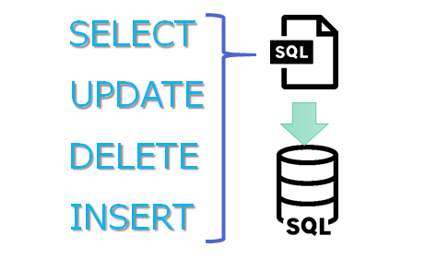

**4.5. Manipulation commands (INSERT, UPDATE, DELETE, SELECT queries)**

<https://github.com/sanjeevlcc/notes_2081/blob/main/DBMS_BIM_BSCIT_BCA/LABS_ON_AIR/3_LAB%202%20-%20creating%20database%20and%20tables%20%2C%20inserting%20data%20with%20some%20constraints.txt>

**4.5. Functions - aggregate functions**

[***https://github.com/sanjeevlcc/notes_2081/blob/main/DBMS_BIM_BSCIT_BCA/LABS_ON_AIR/10_LAB%209%20%20LIMIT-OFFSET%20AGGREGATE%20UPDATE%20NULL***](https://github.com/sanjeevlcc/notes_2081/blob/main/DBMS_BIM_BSCIT_BCA/LABS_ON_AIR/10_LAB%209%20%20LIMIT-OFFSET%20AGGREGATE%20UPDATE%20NULL)

**Built-in functions – numeric, date, string functions,**

**set operations, sub-queries,**

[*https://github.com/sanjeevlcc/notes_2081/blob/main/DBMS_BIM_BSCIT_BCA/LABS_ON_AIR/3_LAB%202%20-%20creating%20database%20and%20tables%20%2C%20inserting%20data%20with%20some%20constraints.txt*](https://github.com/sanjeevlcc/notes_2081/blob/main/DBMS_BIM_BSCIT_BCA/LABS_ON_AIR/3_LAB%202%20-%20creating%20database%20and%20tables%20%2C%20inserting%20data%20with%20some%20constraints.txt)

[*https://github.com/sanjeevlcc/notes_2081/blob/main/DBMS_BIM_BSCIT_BCA/LABS_ON_AIR/13_LAB%2012%20%20JOINS.txt*](https://github.com/sanjeevlcc/notes_2081/blob/main/DBMS_BIM_BSCIT_BCA/LABS_ON_AIR/13_LAB%2012%20%20JOINS.txt)

**Use of group by, having, order by, LIKE Pattern, Exist, Any, All, BETWEEN, join and its types, view and its types.**

<https://github.com/sanjeevlcc/notes_2081/blob/main/DBMS_BIM_BSCIT_BCA/LABS_ON_AIR/13_LAB%2012%20%20JOINS.txt>

<https://github.com/sanjeevlcc/notes_2081/blob/main/DBMS_BIM_BSCIT_BCA/LABS_ON_AIR/5_LAB%204%20and%20or%20not%20operator%20with%20select%20where%20clause.txt>

<https://github.com/sanjeevlcc/notes_2081/blob/main/DBMS_BIM_BSCIT_BCA/LABS_ON_AIR/6_LAB%205%20IN%20and%20BETWEEN%20operator%20with%20select%20where%20clause.txt>

<https://github.com/sanjeevlcc/notes_2081/blob/main/DBMS_BIM_BSCIT_BCA/LABS_ON_AIR/7_LAB%206%20LIKE%20operator%20with%20select%20where%20clause.txt>

<https://github.com/sanjeevlcc/notes_2081/blob/main/DBMS_BIM_BSCIT_BCA/LABS_ON_AIR/6_LAB%205%20IN%20and%20BETWEEN%20operator%20with%20select%20where%20clause.txt>

<https://github.com/sanjeevlcc/notes_2081/blob/main/DBMS_BIM_BSCIT_BCA/LABS_ON_AIR/7_LAB%206%20LIKE%20operator%20with%20select%20where%20clause.txt>

<https://github.com/sanjeevlcc/notes_2081/blob/main/DBMS_BIM_BSCIT_BCA/LABS_ON_AIR/8_LAB%207%20REGULAR%20EXPRESSION%20operator%20with%20select%20where%20clause.txt>

<https://github.com/sanjeevlcc/notes_2081/blob/main/DBMS_BIM_BSCIT_BCA/LABS_ON_AIR/9_LAB%208%20ORDER%20BY%20and%20DISTINCT%20operator%20with%20select%20where%20clause.txt>

<https://github.com/sanjeevlcc/notes_2081/blob/main/DBMS_BIM_BSCIT_BCA/LABS_ON_AIR/13_LAB%2012%20%20JOINS.txt>

**Q/A**

**Fill in the Blanks (20 Questions)**

1. The full form of SQL is __________.
2. __________ is a language used to interact with databases.
3. The SQL command used to create a table is __________.
4. In SQL, __________ is used to retrieve data from a table.
5. The command used to delete a row from a table is __________.
6. __________ command is used to modify the structure of an existing table.
7. In SQL, the data type for storing whole numbers is __________.
8. The __________ operator is used to combine multiple conditions in a WHERE clause.
9. A __________ is a field in a table that uniquely identifies each record.
10. __________ is used to remove constraints or entire tables in SQL.
11. The __________ operator is used to search for a specified pattern in a column.
12. The command used to insert data into a table is __________.
13. A __________ key uniquely identifies a record in another table.
14. A __________ function returns the number of rows that match the specified criteria.
15. The SQL clause __________ is used to filter records after an aggregation.
16. __________ is used to sort the result set in either ascending or descending order.
17. A __________ join returns all rows when there is a match in one of the tables.
18. The __________ operator is used to compare a value to a list of values.
19. The __________ command is used to update existing records in a table.
20. __________ data type is used for storing dates and times in SQL.
21. The __________ operator checks whether a value is within a specified range.
22. The __________ function in SQL is used to return the current system date.
23. A __________ key ensures that no two rows have the same value in the specified column.
24. A __________ query is a query within another query.
25. __________ is used to specify a condition that a record must meet to be included in a result set.
26. The __________ command is used to define constraints like PRIMARY KEY or UNIQUE in a table.
27. The __________ operator is used to combine the results of two or more SELECT statements.
28. The __________ operator in SQL ensures that a value is present in a subquery.
29. The __________ function is used to calculate the sum of a numeric column.
30. The __________ keyword is used to combine rows from two or more tables based on a related column.

**Multiple Choice Questions (20 Questions)**

1. Which of the following SQL commands is used to create a database?
   * a) CREATE DATABASE
   * b) CREATE TABLE
   * c) INSERT INTO
   * d) ALTER DATABASE
2. What does DML stand for in SQL?
   * a) Data Manipulation Language
   * b) Data Modeling Language
   * c) Data Markup Language
   * d) Data Management Language
3. Which of the following is a valid data type in SQL?
   * a) INTEGER
   * b) FLOAT
   * c) VARCHAR
   * d) All of the above
4. Which command is used to modify an existing record in a database?
   * a) UPDATE
   * b) INSERT
   * c) DELETE
   * d) ALTER
5. The SQL operator “BETWEEN” is used for:
   * a) Range checks
   * b) Pattern matching
   * c) Joining tables
   * d) Subqueries
6. Which of the following is NOT a SQL aggregate function?
   * a) COUNT
   * b) MAX
   * c) AVG
   * d) UPDATE
7. Which of the following operators is used to combine the results of two SELECT statements?
   * a) AND
   * b) UNION
   * c) OR
   * d) EXISTS
8. A table’s PRIMARY KEY must be:
   * a) Nullable
   * b) Unique and not null
   * c) Non-unique
   * d) Nullable but not unique
9. Which clause is used to filter records after a GROUP BY?
   * a) ORDER BY
   * b) HAVING
   * c) WHERE
   * d) GROUP BY
10. What is the default sorting order of the ORDER BY clause?

* a) Descending
* b) Ascending
* c) Random
* d) None of the above

1. Which SQL clause is used to filter records before grouping?

* a) ORDER BY
* b) HAVING
* c) WHERE
* d) GROUP BY

1. A __________ join returns records with matching values in both tables.

* a) LEFT JOIN
* b) RIGHT JOIN
* c) INNER JOIN
* d) OUTER JOIN

1. Which SQL function is used to calculate the total of a numeric column?

* a) SUM
* b) AVG
* c) COUNT
* d) MAX

1. The SQL query SELECT * FROM table WHERE name = "John" ORDER BY name DESC sorts the results in:

* a) Ascending order
* b) Descending order
* c) Alphabetical order
* d) Reverse alphabetical order

1. The __________ keyword is used to check if a value is present in a subquery.

* a) IN
* b) LIKE
* c) EXISTS
* d) BETWEEN

1. Which of the following statements is used to delete a record in SQL?

* a) REMOVE
* b) DELETE
* c) DROP
* d) ERASE

1. Which SQL command is used to add new data to a table?

* a) UPDATE
* b) INSERT INTO
* c) ADD
* d) SELECT

1. A unique constraint ensures that:

* a) All values in a column are unique
* b) All values in a column are non-null
* c) A column can have duplicate values
* d) A column has only numeric values

1. The SQL command used to remove a table from a database is:

* a) DROP TABLE
* b) DELETE TABLE
* c) REMOVE TABLE
* d) DELETE DATABASE

1. The SQL clause "ORDER BY" is used to:

* a) Sort the result set
* b) Filter the result set
* c) Group the result set
* d) Aggregate the result set

1. Which SQL command is used to modify the structure of an existing table?

* a) ALTER TABLE
* b) UPDATE TABLE
* c) MODIFY TABLE
* d) ADD COLUMN

1. The "AND" operator is used in SQL to:

* a) Combine two queries
* b) Filter records based on multiple conditions
* c) Sort records
* d) Specify the column order

1. The SQL "LIKE" operator is used for:

* a) Pattern matching
* b) Sorting records
* c) Subquery results
* d) Joining tables

1. The "EXISTS" operator is used to:

* a) Check if a subquery returns any records
* b) Combine multiple SELECT statements
* c) Sort records in ascending order
* d) Match patterns in string values

1. Which of the following is NOT a type of join in SQL?

* a) INNER JOIN
* b) OUTER JOIN
* c) CROSS JOIN
* d) RANDOM JOIN

1. Which SQL function is used to calculate the average of a numeric column?

* a) COUNT
* b) AVG
* c) SUM
* d) MIN

1. In SQL, the “NOT NULL” constraint ensures that:

* a) A column cannot contain null values
* b) A column must be unique
* c) A column must be indexed
* d) A column must contain at least one value

1. The “HAVING” clause is used to:

* a) Filter records after grouping
* b) Filter records before grouping
* c) Sort records
* d) Join two tables

1. Which SQL command is used to remove a constraint?

* a) DELETE
* b) DROP
* c) ALTER
* d) REMOVE

1. In SQL, the "DISTINCT" keyword is used to:

* a) Retrieve unique records
* b) Delete duplicate records
* c) Join multiple tables
* d) Sort records

**Short Questions (20 Questions)**

1. What is SQL?
2. Explain the difference between DDL and DML.
3. What is the purpose of a Primary Key in a table?
4. Describe the difference between INNER JOIN and LEFT JOIN.
5. What are aggregate functions in SQL? Give examples.
6. Explain the role of the WHERE clause in SQL.
7. What does the "DISTINCT" keyword do in SQL?
8. What is a foreign key?
9. What is the use of the "LIKE" operator in SQL?
10. Describe the purpose of the "GROUP BY" clause in SQL.
11. How does the HAVING clause differ from the WHERE clause?
12. What is the difference between DELETE and TRUNCATE in SQL?
13. How do you update a record in SQL?
14. What is a subquery in SQL?
15. Define the term "SQL injection."
16. What is the "BETWEEN" operator in SQL?
17. What is the function of the "ORDER BY" clause in SQL?
18. What does the SQL "JOIN" operation do?
19. How do you create a view in SQL?
20. What is the use of the "COUNT" function in SQL?

**Comprehensive Questions (20 Questions)**

1. Explain the different SQL data types with examples.
2. Discuss the various types of joins in SQL.
3. How do you create and modify a table in SQL? Provide examples.
4. Explain the role of the "INSERT", "UPDATE", and "DELETE" commands in SQL.
5. Discuss the purpose of aggregate functions in SQL with examples.
6. What is normalization in SQL, and why is it important?
7. Describe the use of the "EXISTS" operator in SQL.
8. Explain the concept of indexing in SQL.
9. What are subqueries, and how are they used in SQL?
10. Describe the use of the "IN" operator in SQL.
11. Explain the importance of constraints in SQL. Provide examples.
12. How can you prevent SQL injection attacks?
13. Discuss the difference between "INNER JOIN" and "OUTER JOIN" in SQL.
14. What are the different types of constraints in SQL, and how do they function?
15. Explain how SQL handles date and time functions.
16. How does the "BETWEEN" operator work in SQL?
17. Discuss the significance of the "HAVING" clause in SQL.
18. Explain how the "GROUP BY" clause functions in SQL with examples.
19. What is the purpose of the "ALTER" command in SQL?
20. Describe how SQL handles sorting and filtering data.

***Answers of Fill in the Blanks***

1. *Structured Query Language (SQL)*
2. *SQL*
3. *CREATE TABLE*
4. *SELECT*
5. *DELETE*
6. *ALTER TABLE*
7. *INT*
8. *AND / OR*
9. *Primary Key*
10. *DROP*
11. *LIKE*
12. *INSERT*
13. *Foreign Key*
14. *COUNT*
15. *HAVING*
16. *ORDER BY*
17. *LEFT JOIN / RIGHT JOIN*
18. *BETWEEN*
19. *UPDATE*
20. *DATETIME / DATE*
21. *BETWEEN*
22. *CURRENT_DATE or NOW*
23. *UNIQUE*
24. *Subquery*
25. *WHERE*
26. *CREATE TABLE*
27. *UNION*
28. *EXISTS*
29. *SUM*
30. *JOIN*

***Answers of Multiple-Choice Questions***

1. *a) CREATE DATABASE*
2. *a) Data Manipulation Language*
3. *d) All of the above*
4. *a) UPDATE*
5. *a) Range checks*
6. *d) UPDATE*
7. *b) UNION*
8. *b) Unique and not null*
9. *b) HAVING*
10. *b) Ascending*
11. *c) WHERE*
12. *c) INNER JOIN*
13. *a) SUM*
14. *b) Descending order*
15. *a) IN*
16. *b) DELETE*
17. *b) INSERT INTO*
18. *a) All values in a column are unique*
19. *a) DROP TABLE*
20. *a) Sort the result set*
21. *a) ALTER TABLE*
22. *b) Filter records based on multiple conditions*
23. *a) Pattern matching*
24. *a) Check if a subquery returns any records*
25. *d) RANDOM JOIN*
26. *b) AVG*
27. *a) A column cannot contain null values*
28. *a) Filter records after grouping*
29. *c) ALTER*
30. *a) Retrieve unique records*